Data Engineering Lab
SQL, Linux, AWS and Azure Practical Record
Name: Yedoti Premchand
Program: B.Tech Computer Science Engineering
University: Jain (Deemed-to-be University), Bengaluru

SQL Query to Find the Second Highest Salary
To find the second highest salary from the employees table using MySQL.
- Created the employees table (emp_id, emp_name, dept_name, salary) and inserted 8 records.
- Used a subquery: the maximum salary that is less than the overall maximum salary.
- Highest salary is 80000, so the second highest salary is 75000.
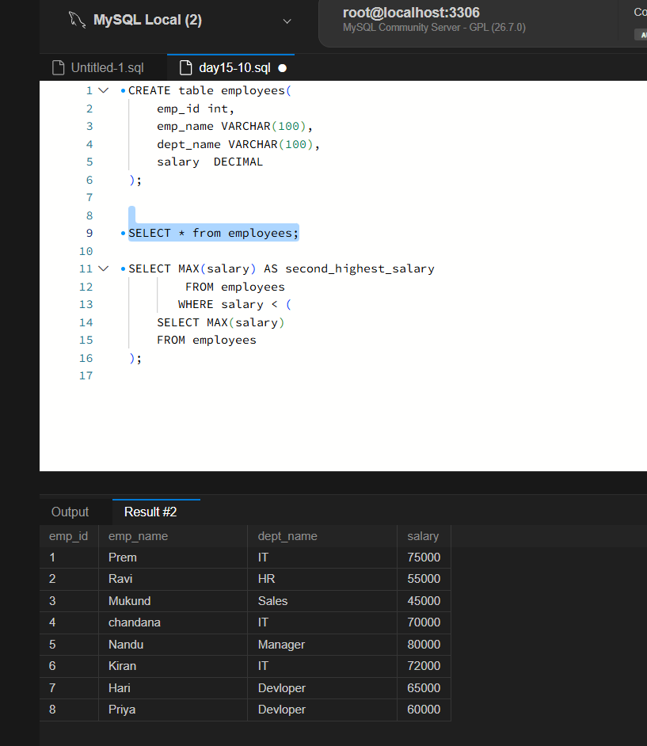
Figure 1.1: Table creation, data and query in MySQL Workbench
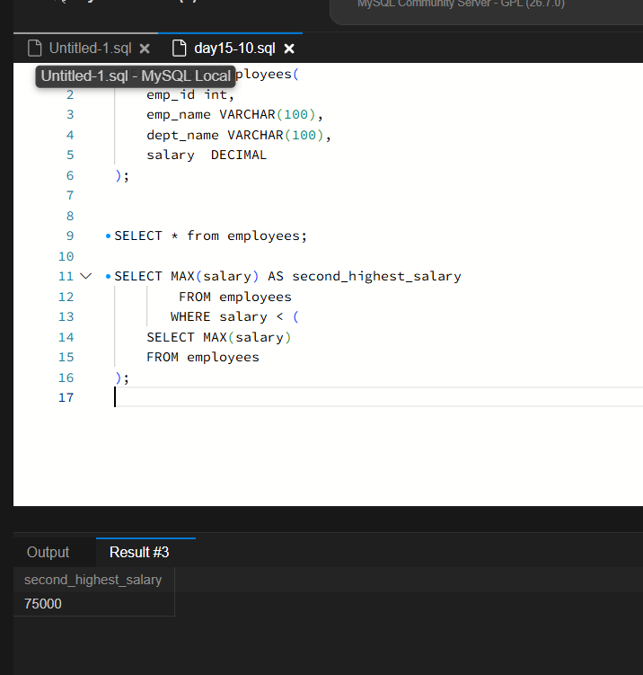
Figure 1.2: Query output, second_highest_salary = 75000

Linux Commands
To show the current working directory, create a directory, create two files, and list the files with their path.
- pwd shows the current directory; mkdir creates the directory; touch creates two files.
- ls -l lists the files with permissions; cd moves into the directory and pwd confirms the path.
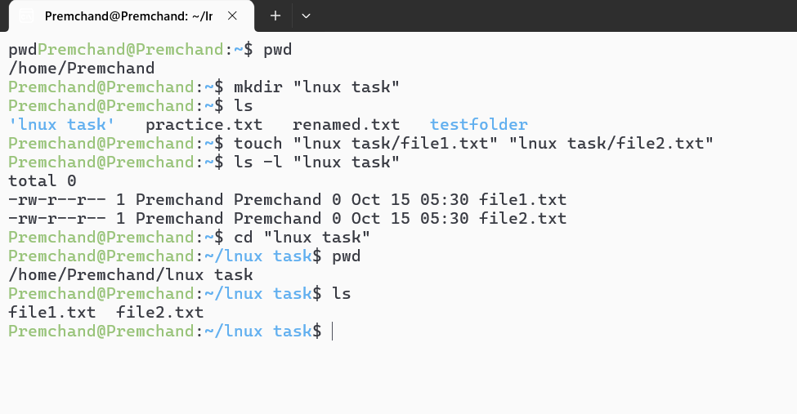
Figure 2.1: Linux terminal output

AWS EC2 Instance Details
To check the current state, instance type and public IP address of an EC2 instance.
- Instance name: dat15-10
- Instance state: Running
- Instance type: t2.micro
- Availability zone: us-east-1d
- Public IPv4 address: 34.207.250.147
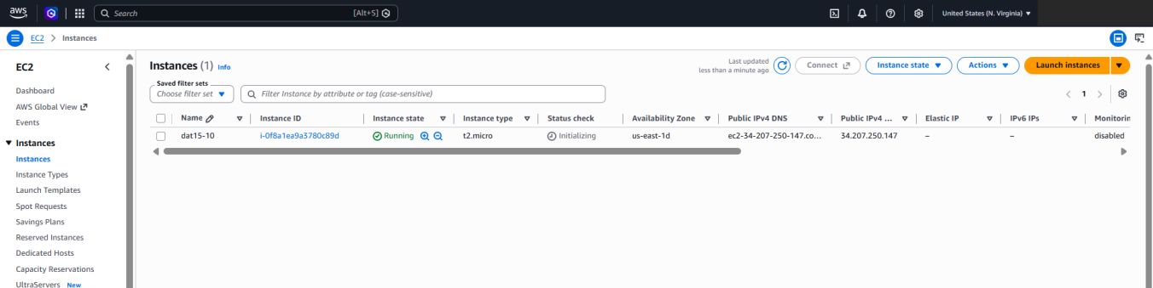
Figure 3.1: EC2 instance details

AWS IAM Role with S3 Read-Only Permission
To create an IAM role for S3 and add the S3 read-only permission.
- Created the role day15-10 with AWS service S3 as the trusted entity.
- Attached the S3 read-only permission policy to the role.
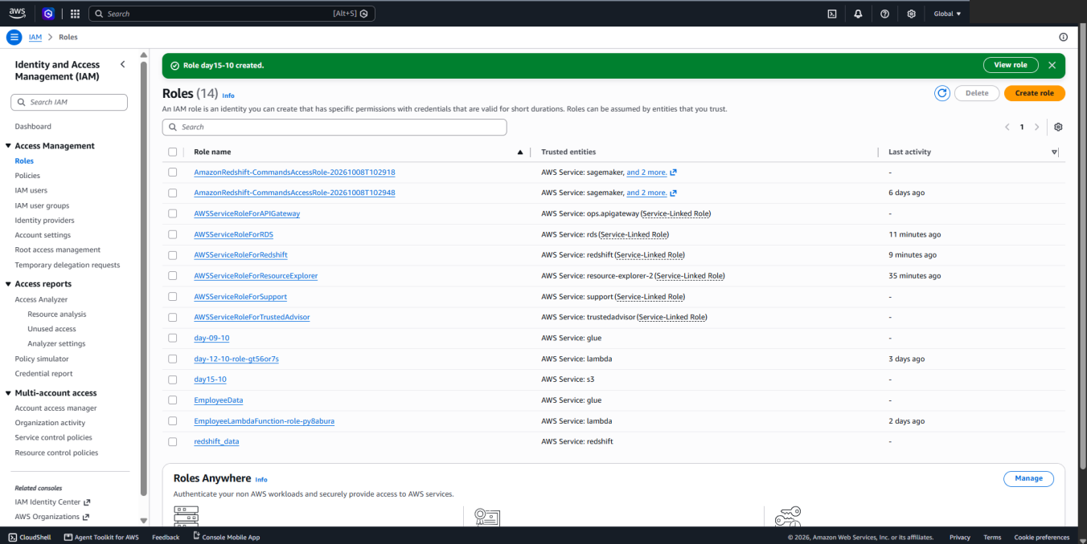
Figure 4.1: IAM role created successfully

Upload a File to an S3 Bucket
To upload a file to an Amazon S3 bucket.
- Bucket: day15-10
- File uploaded: customer_records.csv (text/csv, 196 B)
- Status: Upload succeeded
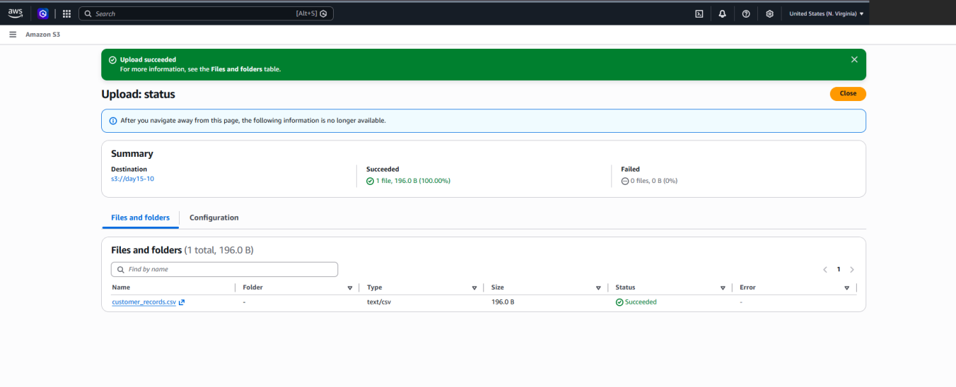
Figure 5.1: S3 upload status

Azure Resource Group
To create a resource group in Microsoft Azure.
- Resource group name: ParcticalRG
- Subscription: Azure for Students
- Region: East Asia
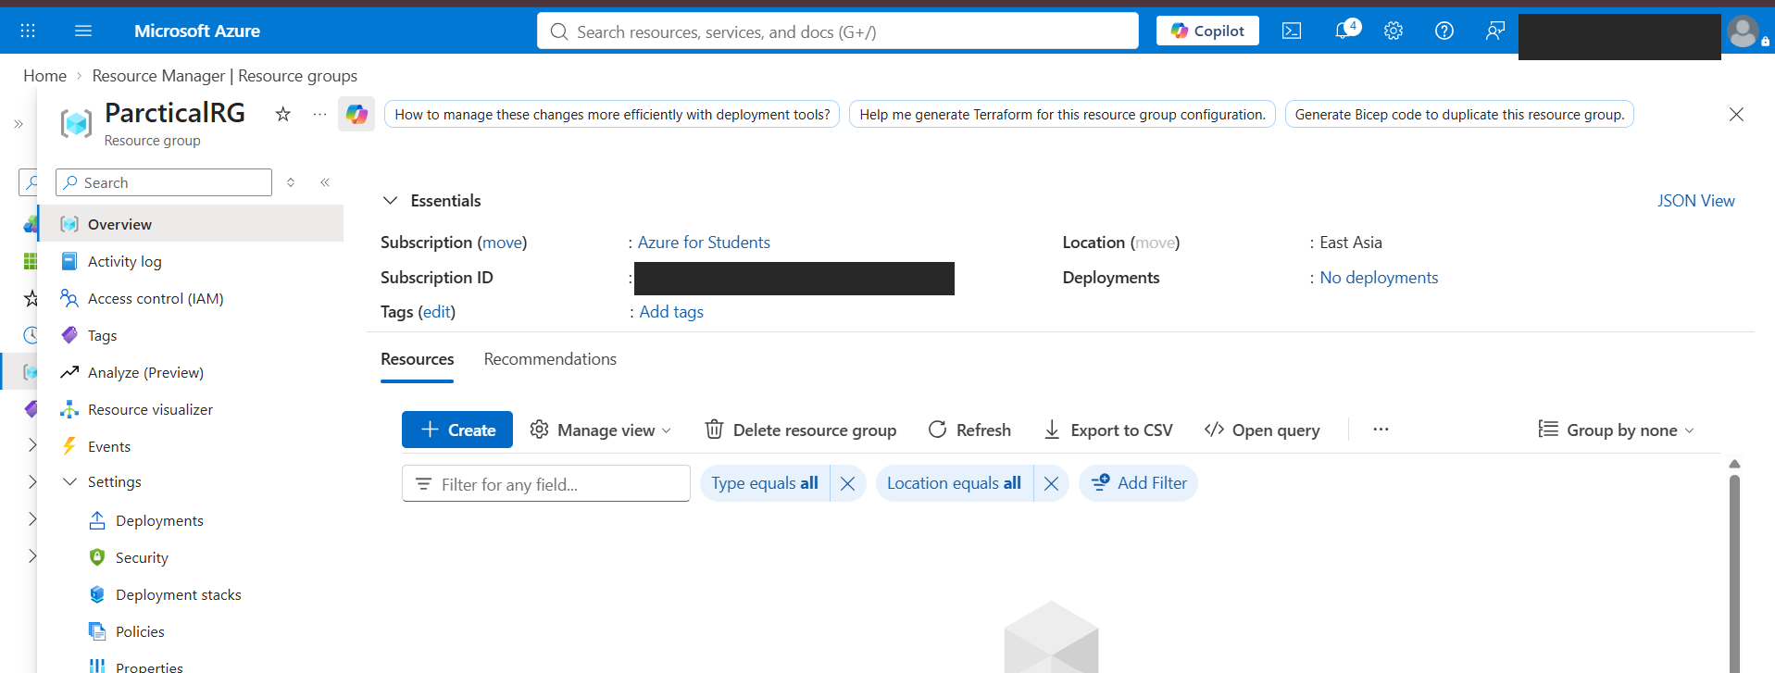
Figure 6.1: Azure resource group overview

